
ALL INDIA BANK OFFICERS’ CONFEDERATION
(Registered under the Trade Unions Act 1926, Registration No.:3427/Delhi)
C/o Bank of India, Parliament Street Branch
PTI Building, 4, Parliament Street, New Delhi: 110001
Phone:011-23730096 Tel/Fax 23719431
E-Mail: aiboc.sectt@gmail.com

CircularNo. 2015/03 Date: 13/01/2015

TO GENERAL SECRETARIES OF ALL AFFILIATES/STATE SECRETARIES

Dear Comrade,

OUR CONTINUING STRUGGLE FOR SALARY REVISION

As a part of our ongoing struggle for salary revision, the UFBU had declared one day All India strike on 7th January,2015 and four days continuous strike all over the country from 21st January,2015 to 24th January, 2015, besides various other agitation programmes.During the extended discussions of UFBU with IBA on 7th January 2015, noticing certain forward movements in the talks, UFBU decided to defer the All India One Day Strike scheduled on 7th January, 2015, with a view to create an amicable atmosphere to pursue the discussion.

During the discussion on 07/01/2015, on our insistence to improve the offer from 12.5%, IBA responded that they need some time for discussion among themselves for the same. While agreeing to continue the discussion at regular and frequent intervals to complete the entire process shortly, it was also decided to form various sub-committees to discuss on the issues like hospitalisation reimbursement, 5 day's Banking and regulated working hours. (IBA has today fixed the dates of meetings of the sub committees. First such sub-group to discuss Charter of Demands of Officers is scheduled to meet on 14th January, 2015 at 2 p.m. at Mumbai.)

These above said developments were communicated to all our affiliates and members vide our Circular No. 2015/02 dated 8/01/15. It could have been understood unambiguously from the enumerated elaborations in the said circular that:

- 12.5 % was not final.
- 4 days strike scheduled on 21/01/15 to 24/01/15 is not deferred.

Nevertheless, we are receiving constant enquiries from our cadres and members besides few rumours on the issues of final wage settlement and proposed strike action scheduled for 21/01/15 to 24/01/15. With a view to quell all rumours, misunderstandings and also to invite all the cadres to be in readiness to pursue our agitation, we reiterate that:

- 12.5 % is not final and our endeavour to impress the IBA is on to improve their offer to meet the expectation of the Bank Employees and Officers.
- Our strike action scheduled from 21/01/15 to 24/01/15 will be carried out as planned, if IBA does not initiate immediate steps to raise their offer to meet the genuine demands and aspirations of the Bank Officers and Employees.

Comrades, AIBOC is committed to strive with all the might in its store to achieve better working condition for the work force of the Banking Sector in general and Bank Officers in particular. While we request all the cadres not to lend ears to the rumours and misinformation, we also request all to magnify ourcollective power with a conviction to achieve our genuine demands.
LETTER WRITTEN BY THE CONVENER OF UFBU TO IBA

We have received a copy of the letter Ref. CM/IBA/2015/102 dated 13th January, 2015 written today by Com. M.V.Murali, Convenor of the UFBU to the Chairman, Indian Banks’ Association (IBA) requesting him to finalise the next date of negotiation for salary revision. Copy of the letter is appended below for your information:

QUOTE:
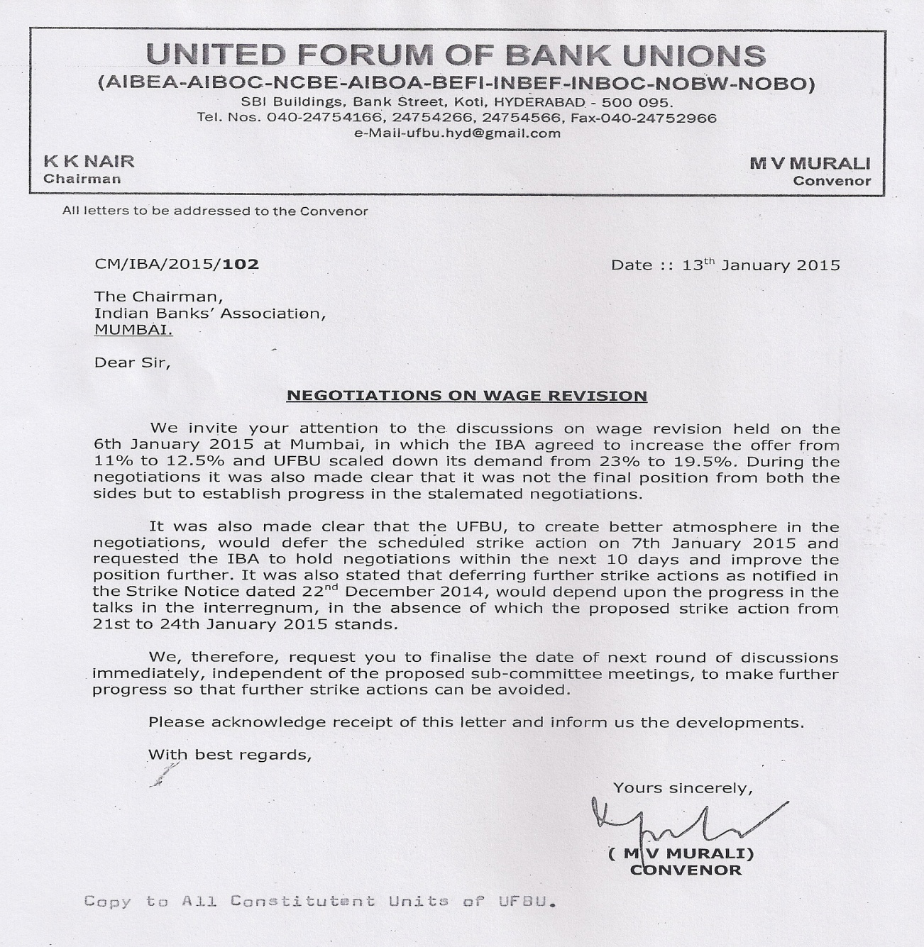
UNQUOTE

With revolutionary greetings,
Comradely yours,
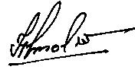
(HARVINDER SINGH)
GENERAL SECRETARY

