ALL INDIA BANK OFFICERS’ CONFEDERATION

(Registered under the Trade Unions Act 1926, Registration No.:3427/Delhi)

C/o Bank of India, Parliament Street Branch

PTI Building, 4, Parliament Street, New Delhi: 110001

Phone:011-23730096 Tel/Fax 23719431

E-Mail: aiboc.sectt@gmail.com

Circular No. 2015/13 Date: 09/02/2015

**TO ALL AFFILIATES / STATE UNITS / MEMBERS**

Dear Comrades,

**CALL FOR 4DAY’S STRIKE FROM 25TH TO 28TH FEBRUARY, 2015**

**& INDEFINITE STRIKE FROM 16TH MARCH**

Please refer to our circular No. 2015/10 advising you about the decision of the UFBU to restart the agitation programme including to observe 4 days strike from 25th to 28th February, 2015 and indefinite strike from 16th March. We wish to inform you that Strike Notice of the strike calls has already been served by Com. M.V. Murli, the convener of the UFBU. Copy of the notice alongwith statement of the case is placed hereunder for your information and records:

**QUOTE:**

**NOTICE OF STRIKE**

**NAME OF UNIONS** : **UNITED FORUM OF BANK UNIONS (U.F.B.U.)**

* ALL INDIA BANK EMPLOYEES’ ASSOCIATION (AIBEA)
* ALL INDIA BANK OFFICERS’ CONFEDERATION (AIBOC)
* NATIONAL CONFEDERATION OF BANK EMPLOYEES (NCBE)
* ALL INDIA BANK OFFICERS’ ASSOCIATION (AIBOA)
* BANK EMPLOYEES FEDERATION OF INDIA (BEFI)
* INDIAN NATIONAL BANK EMPLOYEES FEDERATION (INBEF)
* INDIAN NATIONAL BANK OFFICERS CONGRESS (INBOC)
* NATIONAL ORGANISATION OF BANK WORKERS (NOBW)
* NATIONAL ORGANISATION OF BANK OFFICERS (NOBO)

**NAMES OF ELECTED REPRESENTATIVES**

1. Shri. M.V. Murali, Convenor, UFBU & General Secretary, NCBE
2. Shri. C.H. Venkatachalam, General Secretary, AIBEA
3. Shri. Harvinder Singh, General Secretary, AIBOC
4. Shri. S. Nagarajan, General Secretary, AIBOA
5. Shri. Pradeep Biswas, General Secretary, BEFI
6. Shri. Subhash Sawant, General Secretary, INBEF
7. Shri. K.K. Nair, Chairman, UFBU & General Secretary, INBOC
8. Shri Mohan Kumtakar, General Secretary, NOBW
9. Shri. SU. Deshpande, General Secretary, NOBO

**Dated this day of 5th February, 2015**

**To**

**The Chairman,**

**Indian Banks’ Association,**

**World Trade Centre,**

**Cuffe Parade, Mumbai.**

Sir,

In accordance with the provisions contained in sub-section (1) of Section 22 of the I.D. Act – 1947, we hereby give you notice that the members of all the constituent unions of **United Forum of Bank Unions** ( AIBEA, AIBOC, NCBE, AIBOA, BEFI, INBEF, INBOC, NOBW, NOBO)propose to go on

1. Four days’ Strike from the **25th February 2015 to 28th February 2015**;

and

1. Indefinite Strike from **16th March 2015 onwards**.

**Demanding:**

1. **IMMEDIATE SETTLEMENT OF WAGE REVISION;**
2. **IMMEDIATE RESOLUTION OF OTHER RELATED ISSUES**

**The details of the programme and the Statement of the case are furnished herein.**

**Sd/-**

(M.V. MURALI)

**CONVENOR**

**Encl. : 1. Details of Agitational Programme**

**2. Statement of the Case**

**Copy to**

1. **Chief Labour Commissioner (Central), New Delhi**
2. **CMDs/MDs/CEOs of All Banks**

**ALL INDIA BANK STRIKE**

**PROGRAMMES:**

|  |  |
| --- | --- |
| **9th February 2015** | Centralised Demonstrations at all centres |
| **13th February 2015** | Centralised Demonstrations at all centres |
| **20th February 2015** | Badge Wearing & Demonstrations |
| **23rd February 2015** | Press Meet in all State capitals |
| **24th February 2015** | Centralised Demonstrations at all centres |
| **25th to 28th February 2015** | **FOUR DAYS’ ALL INDIA BANK STRIKE** |
| **16th March onwards** | **INDEFINITE STRIKE** |
| **Other Action Programmes in the interregnum**  **between 1st March 2015 and 15th March 2015** | |

**STATEMENT OF THE CASE**

1. **DEMANDING IMMEDIATE WAGE REVISION SETTLEMENT:**

Wages and service conditions in the banking sector are governed by the industry-level bipartite settlements signed between the Indian Banks’ Association (IBA) and the workmen unions and officers’ associations operating in the banking industry. All the banks which have given mandate to IBA to negotiate on behalf of them are parties to the settlements. United Forum of Bank Unions (UFBU), representing five workmen unions and four officers’ associations, is currently negotiating with IBA for revision of wages to bank workmen/officers.

The wage revision for bank employees is due from 01.11.2012 subsequent to the expiry of the last Bipartite Settlement on 31.10.2012. The common charter of demands, separately for workmen and officers, were submitted by UFBU to IBA on 30.10.2012 i.e., before the expiry of last bipartite settlement.

UFBU has been requesting, since the start of negotiations, for a time-bound approach to hold the negotiations on its demands and for conclusion of wage settlement within a reasonable time. But the IBA has inordinately delayed the negotiation process and there is no significant progress in the wage negotiations despite a lapse of nearly two years’ time.

IBA has been adamant in its offer of increase since beginning quoting the reason of non-affordability of banks and even brought stalemate in negotiations by sticking to its offer of 11% in pay slip components for nearly a year. With the intervention of CLC (C) in the last conciliation held on 5th January 2015, the negotiations were held by IBA with UFBU on 6th and 7th January 2015 and IBA increased its offer from 11% to 12.5% in pay slip components, with an assurance to have further flexibility, while UFBU reduced its demand from 23% to 19.5%.

It will not be out of place to mention here that UFBU put on hold its four days’ strike from 21st to 24th January 2015 in the background of an assurance given by IBA towards that they would further pursue the matter with Government and deliberate in the Managing Committee Meeting of IBA to be held on the 31st January 2015 with all sincerity and hold discussions with us in the first week of February 2015 to improve the offer further to reach finality at the earliest.

But, much to our dismay, IBA has backtracked from its assurance and once again with its slogan of non-affordability of banks, offered a paltry increase of 0.5% over the earlier increase offer of 12.5%, which is considered by UFBU as inadequate and not satisfactory. Hence, once again UFBU has been pushed to the path of agitation. With utmost patience, for the last two years, UFBU has been making its best efforts to settle the demands amicably, whereas the flexibility shown by UFBU is not at all being reciprocated by IBA.

We also submit that IBA is not giving any cognizance to the difficulties that are faced by the employees on account of high rate of inflation, which has eroded the salaries of the employees to a great extent and the wage increases considered in other similar Public Sector undertakings despite their low profits.

Further, bank employees, workmen and officers, have been performing well despite severe stress due to substantial increase in workload in the banks on account of opening of many branches under Financial Inclusion and so on despite inadequate staff strength. Bank employees never lagged behind in the successful implementation of all Government sponsored programmes/schemes, including the recently implemented Prime Minister’s Jan Dhan Yojna. However, the bank employees are not being paid adequately.

**HENCE, THIS DEMAND FOR IMMEDIATE SETTLEMENT OF WAGE REVISION.**

1. **IMMEDIATE RESOLUTION OF OTHER RELATED ISSUES:**

The common charter of demands, separately for workmen and officers, were submitted by UFBU to IBA on 30.10.2012 i.e., before the expiry of last bipartite settlement. Several issues relating to workmen and officers other than the wage increase were also listed in the common charter of demands and submitted to IBA are yet to be resolved.

The prominent issues such as **5-day banking, Regulated working hours to officers, Improvements in Pension Scheme, Improvements in other perquisites and allowances, etc.** are yet to be resolved and simultaneous resolution of all those issues listed in the common charter of demands is also essential for expeditious settlement on wages and service conditions.

**HENCE, THIS DEMAND FOR IMMEDIATE RESOLUTION OF OTHER RELATED ISSUES.**

**UNQUOTE**

We also give below the specimen of the Poster and badges. Please ensure that affiliates/state units use this design only :

**SPECIMEN OF THE POSTER**

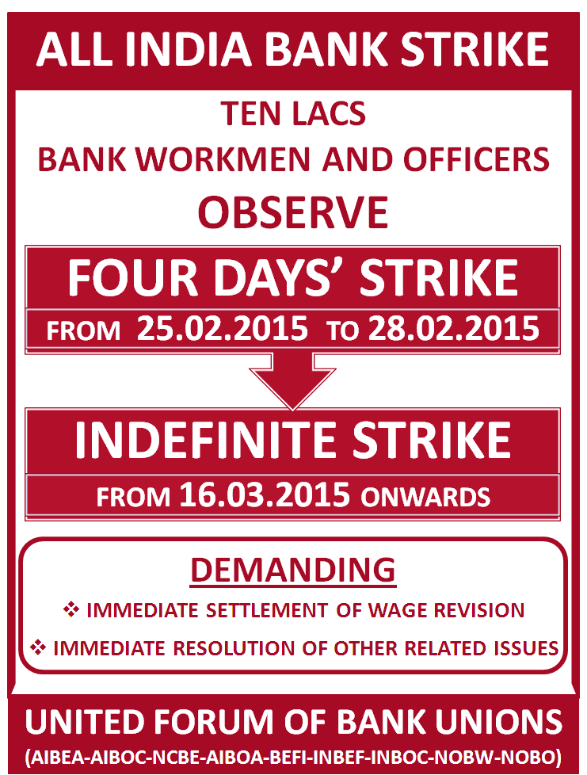

**Specimen of Badge for the Badge Wearing programme on 20.02.2015**

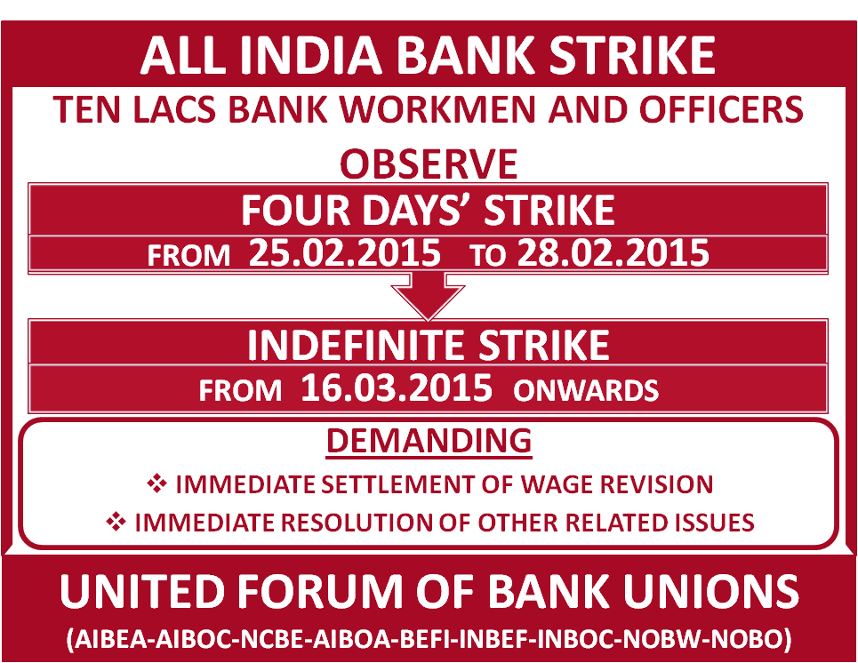

With revolutionary greetings,

Comradely yours,

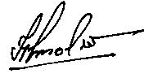

(HARVINDER SINGH)

**GENERAL SECRETARY**