(Registered under the Trade Unions Act 1926, Registration No.3427/Delhi)
6th Floor, E-Block, SamriddhiBhavan, 1, Strand Road, Kolkata -700 001
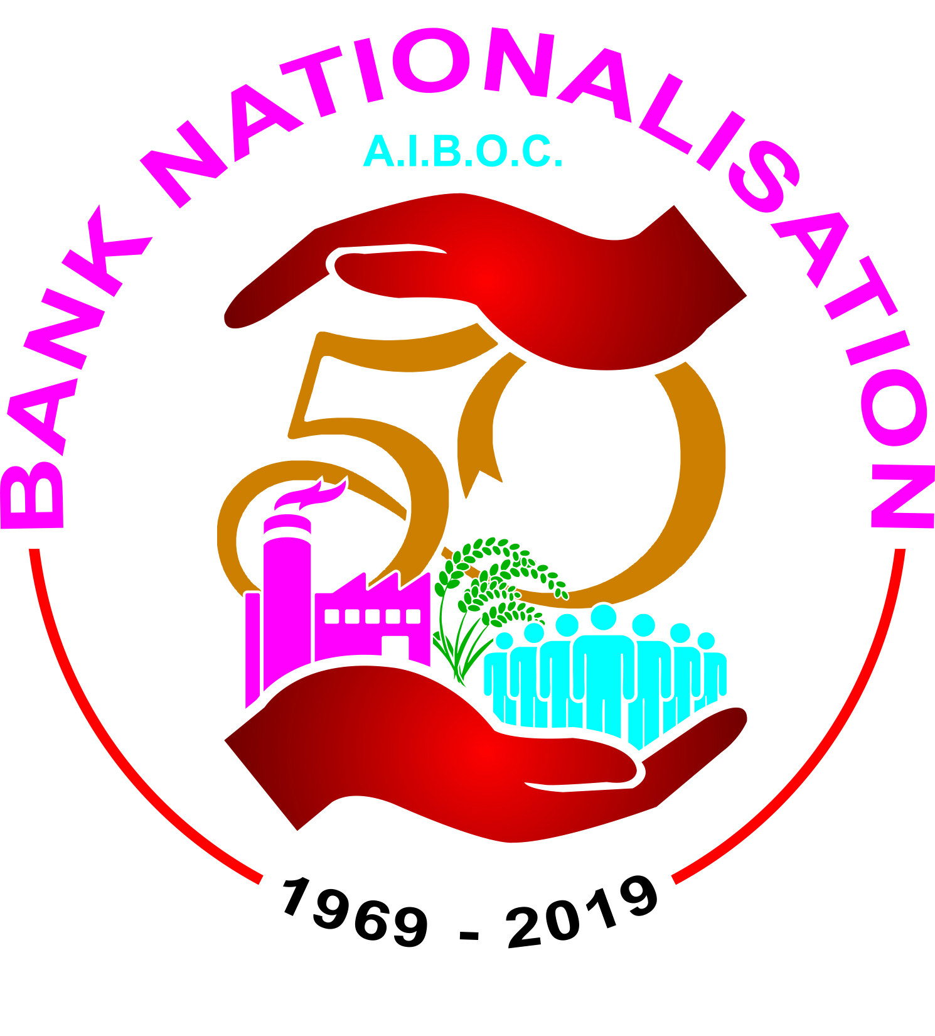
c/o State Bank of India Officers’ Association (Bengal Circle)
Phone: 2210-1234, Fax: (033) 2210-2210
e-mail: aiboc.sectt@gmail.com
soumyadatta.aiboc@gmail.com
website: www.aiboc.org
@aiboc_in

Circular No. 2019/22 Date: 26.03.2019

To All Affiliates/ State Units (Please Circulate)

Strike Call given by Catholic Syrian Bank Officers’ Association (CSBOA) on 02nd April 2019
Fraternal Support by AIBOC

Catholic Syrian Bank Officers’ Association (CSBOA) has given a nationwide strike call in their bank on 02nd April, 2019, protesting against anti-labour policies and multifarious retrograde measures being adopted by the bank management. AIBOC declares fraternal support to striking comrades of CSBOA. The circular issued by CSBOA is appended.

2. You are aware that AIBOC has endorsed and supported all agitation programs launched by CSBOA to uphold the self-esteem and dignity of the officers community of The Catholic Syrian Bank Limited and also to protect the 98 year old institution. AIBOC has written many communiqués in this regard to Department of Financial Services (DFS), RBI, IBA and other stakeholders for their intervention. AIBOC also incorporated resolution of IR issues prevailing at Catholic Syrian Bank as one of the principal demands in the nationwide strike on 21st December 2018. These matters were discussed threadbare with the Central Labour Commissioner (CLC) and later DFS as part of the conciliatory proceedings held at Delhi on 19th December 2018 before the strike dated 21st December 2018.The respected CLC even advised representatives of IBA and DFS to intervene and use their good offices to resolve the issues of CSB immediately. We regret to note that even after a clear directive from the Central Labour Commissioner, the situation did not improve. On the contrary, a slew of fresh retrograde measures were initiated by the Bank management. On 21st January, 2019, by way of an internal circular the retirement age of the officers in CSB was unilaterally reduced to 58 years and then within a few weeks it was reduced to 50. Further, on attaining 50 years of age, ‘performance’ of the officers concerned will be reviewed by a special committee to be appointed by the bank management and if ‘found suitable’, the special committee will extend their service upto 53. Thereafter, all such officers would be subjected to an annual review upto 58 years. Incidentally, the retirement age for officers/ employees is 60 years in the entire banking industry in our country. Therefore, the move of CSB of reduction in retirement age for officers is totally unprecedented and unwarranted. AIBOC strongly feels that these measures are draconian and need to be resisted tooth and nail. Comrades, this is not a fight of CSBOA alone. We call upon each of our affiliates to extend maximum support to the striking comrades of CSBOA so that the strike dated 2nd April, 2019 becomes a resounding success. We enjoin upon our Kerala state unit to involve all stakeholders in all agitation programs chalked out by CSBOA and ensure the total success of the strike.

We would like to make it clear that we shall not deter to escalate this on a national Level once again if issues are not resolved by the bank management for restoration of self-esteem of the officers of The Catholic Syrian Bank. We do hope that good sense will prevail and the bank management will rescind all retrograde measures to instil confidence in the officers’ community, which will go a long way to improve the overall health of the institution.

With revolutionary greetings,
Yours sincerely,
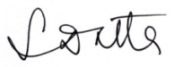

(Soumya Datta)
General Secretary
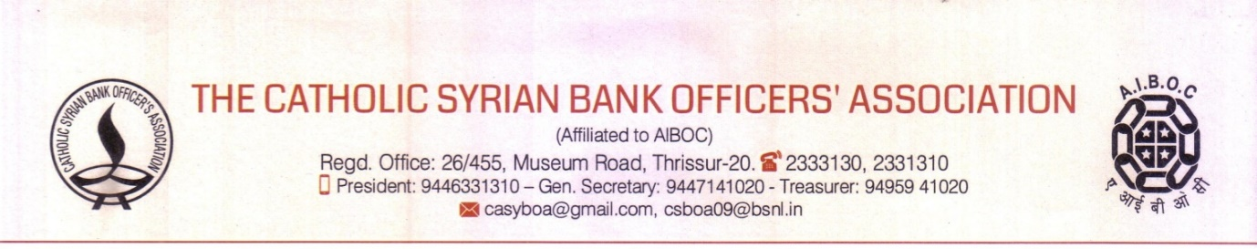
Circular No: 40/2017-19 18th March 2019

Dear Comrades,

Clarion Call from CSBOA... All India Strike on April 2nd 2019
It is with a sense of grief and shock that, everyone inside our beloved institution and all our well-wishers, are watching the events unfolding in our Bank. A Bank, which was making profits continuously until 2014, suddenly finds itself amidst all sorts of problems. We were all working here when the Bank was continuously making profits, whereas the ‘specialists’, who have been entrusted with the responsibility of innovation and leadership, were conspicuously absent then! Despite this glaring fact, we are facing accusations / allegations hurled at employees and officers for non-performance! We are aware that this narrative of non-performance is being sold to many, particularly the external stakeholders, but evidently, such falsehoods have only a very short lifespan.
Through various measures, which we all know and are experiencing day in and day out, we have been firmly pushed against a wall. CSBOA practiced extreme restraint, considering that the interest of the Bank is paramount. Now things have come to a stage where the Management, who have an obligation to keep everyone together, is trying to divide, squandering its energy in demoralising the employees and pursuing an agenda to decimate the trade unions.
The collective feeling of anguish among the Officer fraternity is so great that the proposed strike is perceived to be only the beginning of a long drawn struggle. In spite of the tireless verbal volleys of the Management, which at times crosses all boundaries of decency, the entire employees of CSB know whom to trust and whose words carry more credibility. The events of the past few months have dispelled the lingering doubts in the minds of even the most diehard optimists about what future they can expect under the present Management. Comrades, by refusing to adopt the time tested nationwide practice of positively engaging with the majority officers association, the management is trying to erase a positive work culture that was prevalent in our Bank.
We are convinced that the Managements present narrative is not taking the Bank one inch forward and is in no way benefitting the main stake holders such as, our employees (past and present), our investors & the customers.
Comrades, it is our bounden duty to rise up in unison and declare that ‘enough is enough’.
What can possibly be the response of the Officers and their families who are threatened with such an insensitive statement of exclusion? What can be the normal reaction of a group of people who are faced with the certainty of loss of their livelihood? It is the natural right of everyone to stand up and protest when their right to earn a decent livelihood live is being snatched away. Given that right to life is inseparable from the right to earn a livelihood, CSBOA has taken the firm decision that time has come to converge onto the streets and inform all the stake holders that all is not well in the Bank. We have chosen April 02nd, as we did not want to obstruct business that can accrue in the month of March. This strike call is nothing but a firm assertion that the officer community of our Bank is ready for the long haul to bring about a course correction and safe guard our beloved institution.
The feedbacks that we are getting clearly indicate that apart from our members, all right thinking employees of CSB, cutting across all cadre / scale are aligned with our demands.
AIBOC, our umbrella organization with a membership of more than 320,000, while hailing our move of resistance, has pledged their full-fledged support to our continued action plans. At this juncture, we call upon all the executives and award staff to join this moral struggle. Later on, history will never absolve us of our indifference at this moment of reckoning.
Our demands
1. Unconditional and immediate roll back of unilateral decision to reduce retirement age from 60 to 58 years and the unilateral changes made in the Officers’ Service Regulations.
2. Immediate Roll back of changes made in Service Conditions of Officer Employees vide Cir. No. 24/2019/BC/S-8 dated 28.02.2019 which will reduce the retirement age of Officers to 50 years and also will seriously affect the public interest.
3. Stop the practice of compulsory retirement from service (CRS)
4. Stop issuing notice of cessation to retiring officers and pay their legitimate retirement benefits in time.
5. Stop CTC appointments and absorb all contractual employees in IBA scale and stop the practice of reappointing retired personnel.
6. Give IBA mandate for the 11th Bi partite settlement.
7. Stop the moves to change the name of the Bank and shift the Head/Administrative Office out of Thrissur.
8. Recruit adequate clerical, subordinate and housekeeping staff so as to extend prompt and courteous service at Branch counters.
9. Stop denial of eligible leave and reinstate the eligible allowances which were unilaterally withdrawn.
10. Stop the increasing focus on corporate lending at metros which will alienate the common man from the Bank.
The frenzied reactions of some persons in the Bank at the demand of AIBOC for a forensic audit reveals that that the cat is out of the bag and in case someone appears more perturbed in the coming days, the indications are that a lot more skeletons are still in the cupboard.
We fondly remember the two visits by the National General Secretary of AIBOC to Thrissur to address our issues. All of us are aware of the uneasiness felt in some quarters when our National General Secretary demanded a forensic audit’. The recent imposition of a colossal penalty by the RBI for non-compliance is in the public domain. When charge sheets are being issued with a vengeance for the flimsiest of reasons on lower grade officers, devastating their lives forever how did a loss of such magnitude escape accountability?
We are not fighting for the stars in the sky. We are not even fighting for equality in perks and allowances with officers working in other Banks. We have not raised unreasonable / unjustifiable demands. We are fighting for our self-esteem and our right to earn a decent livelihood and thereby to protect our right to live per se.
Comrades, we are pushed to wall and have only one way to move-forward. Make the April 2nd strike a thundering success.
- Black Badge Day – 26th March 2019
- Signature Campaign – 28th March 2019 to 30th March 2019
- One Day Sathyagraha at Thrissur on 31st March 2019
- Mass Rally at Thrissur on 2nd April 2019 (All Strike Day)
Long live our unity! March on to April 2nd 2019 and let our solidarity convey a strong message.
Yours comradely,
Sd/-
Ramasubrahmanian T N
General Secretary

“Truth will ultimately prevail where there is pains to bring it to light.”

For Circulation among members only

